Microsoft O-365 software

Click the link below to access Microsoft O-365 applications
https://www.office.com/ or use the “SOM email” link from the MedScope landing page

Enter your SOM email address
Your page will re-direct to the UMB SOM login page (w/Davidge Hall background)
Enter your SOM password

Click on the “blue” square icon with the white tic-tac-toe grid to reveal / access other O-365 applications available in the suite.

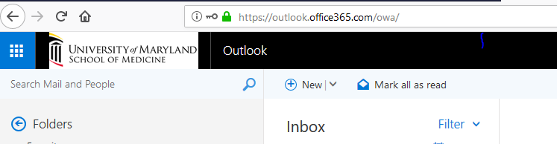

If you wish to install the Microsoft Office application directly on a computer device instead of using the O-365 cloud version you can select the “Install Office” button (In the upper right hand corner ). You are allowed to install Microsoft Office on up to 5 physical devices (PC, Laptop, MacBook)

